CHAPTER 25
CURRENT, RESISTANCE AND ELECTROMOTIVE FORCE
Discussion Questions

Q25.1 No. The statement in Chapter 21 refers to an electrostatic situation where there is no movement of charge. 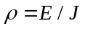 refers to a situation where current is flowing in the conductor, so charges are moving.

Q25.2 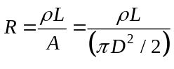, where L is the length and D is the diameter. 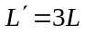 and 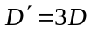 gives 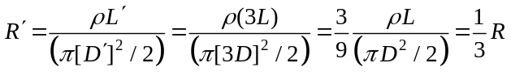.

Q25.3 The resistivity is a property of the material of which the resistor is made and does not depend on the size or shape of the resistor. The resistivity remains .

Q25.4 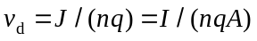. The current , by conservation of charge, is the same in both wires. For smaller cross sectional area the current density increases and the drift speed increases. By Eq.(25.5) the larger current density means the electric field is larger in the smaller wire. The increased electric field provides the force that accelerates the electrons to a higher drift speed.

Q25.5 When current is flowing through the battery in the direction from the negative terminal toward the positive terminal the terminal voltage is 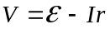. The emf is 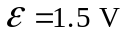and 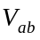 is less than this.

Q25.6 Yes. If current is being pushed through the battery from the to the terminal by another voltage source, as shown in Fig. DQ25.6. The voltage drop 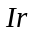 across the internal resistance of the battery is directed opposite to the emf. If this current is large enough the potential of the + terminal of the battery can be lower than the potential of the terminal; 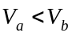.

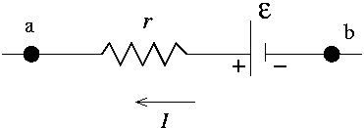

Figure DQ25.6

Q25.7 Yes. The open-circuit voltage is . The short-circuit current is 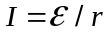so 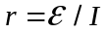.

Q25.8 No. The current the battery provides depends on the total resistance of the circuit connected across the battery terminal. The current depends not only on the battery but also on the rest of the circuit.

Q25.9 A wire carrying a current of 10 A remains electrically neutral. But a huge amount of charge (10 C) passes a cross section of the wire each second.

Q25.10 (a) The current is the same on both sides of the resistor so the current density is the same. 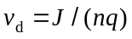 so the drift speed is the same on both sides of the resistor. (b) The electric potential is higher at the end of the resistor when the conventional current enters. Electrons move opposite to the direction of the conventional current so move to higher potential. Negative charge loses potential energy when it goes to higher potential. Electrons lose electrical potential energy when they pass through the resistor.

Q25.11 (a) For a resistor 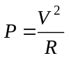. When the temperature increases the resistance of the copper heating element increases. Since is constant, the electrical power consumed by the resistor decreases. (b) For carbon the temperature coefficient of resistivity is negative (Table 25.2) and the resistance of the carbon cylinder decreases when its temperature increases. Therefore, the electrical power it consumes increases. It is a general rule that the resistance of a metallic conductor, like copper, increases as the temperature increases. And the resistance of a semiconductor (carbon is an example) decreases as its temperature increases.

Q25.12 If the resistor is made of a metal its resistance increases with temperature, and the greater the current the greater the temperature of the resistor. Ohm’s law says 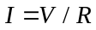 and a graph if I versus V is a line with slope 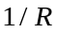. But since R increases when V and I increase, the slope decreases as V increases. This behavior corresponds to graph (d).

Q25.13 Resistance increases with temperature so the current through the bulb decreases when the bulb heats up. Current through the bulb is largest when the light is first turned on.

Q25.14 In (a) the same current flows through each bulb and they have equal brightness. In (b) the resistance is halved so the current is doubled compared to (a) and bulb is brighter.

Q25.15 (a) In both circuits the same current flows through the ammeter. The current is the same everywhere in the circuit, current doesn’t get “used up” when it passes through the bulb. (b) Since the current through the bulb is the same in both circuits the bulb is the same brightness.

Q25.16 An ideal ammeter is a very low resistance device and does not add resistance to the circuit. An ideal voltmeter is a very high resistance device and adds a very large resistance in series with the light bulb. In (b) the total circuit resistance is very large and the current through the bulb is very small. The bulb will be much brighter in (a).

Q25.17 In both the charging process and when the battery delivers energy to a circuit some energy is lost to thermal energy as the current flows through the internal resistance of the battery.

Q25.18 No, their internal resistance is too high. They wouldn’t be able to supply enough current to start the car.

Q25.19 The electrical energy delivered to a device is 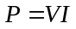. Larger means smaller . Energy loss in the wires occurs at a rate 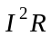 so if is smaller can be larger and the circuit still have the same rate of energy loss in the wires. Thinner wires have larger .

Q25.20 The electrical energy delivered to a device is . Larger means smaller . Energy loss in the wires occurs at a rate so if is smaller then there is less energy loss due to the resistance of the transmission lines. A disadvantage is the danger of high voltages and the need to step up and step down the voltage before and after transmission.

Q25.21 The voltage of the electrical system in each case is matched to the power that must be delivered to the devices in the system. The lower voltage in an automobile system requires higher currents but the electrical transmission distances are small so losses due to wire resistance is tolerable. Also, the lower voltage auto system is safer. It is more common for untrained people to poke around under the hood of a car than to get involved in their household wiring.

Q25.22 It should have low resistance and a melting point of the desired value.

Q25.23 The larger internal resistance limits the short-circuit current.

Q25.24 The energy transported by the electrical current is much larger than the heat energy conducted in the opposite direction. The potential difference drives the electrons in one direction. To conduct heat they would have to travel in the opposite direction.

